Goal Question Metrics Guidelines



Table of Contents

1 Purpose 3
2 GQM Hierarchy 3
3 GQM Implementation 7
4 GQM Architecture 8
4.1) Inputs from the Practice 9
4.2) Outputs from the Practice 10
4.2.1) Communicate project or program status 10
4.2.2) Provide meaningful measurement results decision-makers 10
4.2.3) Assess the value of processes, tools and techniques 10

- Purpose
The Goal-Question-Metric (GQM) method is used to define measurement on the software project, process, and product in such a way that
- Resulting metrics are tailored to the organization and its goal
- Resulting measurement data play a constructive and instructive role in the organization
- Metrics and their interpretation reflect the values and the viewpoints of the different groups affected (e.g., developers, users, and operators)
- GQM Hierarchy
GQM defines a measurement model on three levels:
- Conceptual level (goal): A goal is defined for an object, for a variety of reasons, with respect to various models of quality, from various points of view, and relative to a particular environment.
- Operational level (question): A set of questions is used to define models of the object of study and then focuses on that object to characterize the assessment or achievement of a specific goal.
- Quantitative level (metric): A set of metrics, based on the models, is associated with every question in order to answer it in a measurable way.
Although originally used to define and evaluate a particular project in a particular environment, GQM can also be used for control and improvement of a single project within an organization running several projects.

Conceptual Level
Goals identify what we
Want to accomplish
Relative to products, Processes or resources
Goal 1
Goal 2
Operational Level
Questions helps us how to understand how to meet the goal. They address the context of quality issues of particular viewpoint
Q 1
Q 2
Q 3
Q 4
Q 5
Quantitative Level
Metrics identify the measurements that are needed to answer the questions.
M 1
M 6
M 5
M 4
M 3
M 2
Fig 1: Basic GQM Hierarchy

According to the GQM approach, organizational measurement goals have to be defined.
Following are the organizational measurement goals decided by SEPG, in the initial phase as part of the process improvement program.
- Improve Customer Satisfaction
- Increase in profitability margin %
These are the current goals and could change over a period

  - Goal 1: Improve Customer Satisfaction

Objectives:

- To increase the Customer satisfaction Index

- Deliver defect free product or project to the clients / customers

- Deliver the project on time with compliance to planned efforts and schedule

Questions to achieve the goal:

- How to capture the customer satisfaction survey?
- What is our CS level now?
- Is the CS is improving over time?
- How to check the internal employee satisfaction?
- How to reduce defects in product / work products delivery?
- How to deliver the project on time?

Entities, Attributes and Metrics

Entities | Attributes | Related Metrics
Customer Satisfaction Index(CSI) | - CSI rating (1-5) | - Customer Satisfaction survey
Delivered Defect Density (UAT Defects) | - Size of the project  - Defect logged by user | - UAT testing defects  - Defects reported by clients
Schedule Variance (SV) | - Actual Start date  - Actual end date  - Planed start date  - Planed end date | - Requirement schedule variance  - Design schedule variance  - CUT schedule variance  - SIT schedule variance  - Overall schedule variance

  - Goal 2: Increase profit margin %

Objectives
- To increase the productivity
- To reduce the operational cost
- To reduce the effort variance
- To reduce the rework effort

Questions to achieve the goal
- How to measure Productivity? Is it improving?
- How to measure the functional knowledge? How effective are we finding defects?
- How to measure Cost of Operations? How we can reduce it?
- How to measure the effort variance

Entities, Attributes and Metrics

Entities | Attributes | Metrics/Measures
Productivity | - Actual efforts spent in the SDLC phases  - Size of the project | - Test Case Design Rate  - Test case Review Preparation Effort  - Test cases Review Rate  - Requirements Understanding effort spent by tester per FP  - Test case Development effort per FP  - Test Case Review Effort  - Code Review Preparation Effort  - Code Review Rate  - Code Review Effort  - Unit Test Case Design Rate  - Unit Test case Review preparation Effort %  - Unit Test cases Review Rate  - Unit Test case Review Effort%  - Unit Test case Development effort per FP  - Requirements Review Rate  - Requirements Review Effort  - Requirements Analysis Effort  - Requirements understanding effort by designer per FP  - Design Review Preparation Effort  - Design Review Rate  - Design Review Effort  - Requirements understanding effort by Developer/coder per FP
Internal Defect Density(Internal defects) | - Size of the project  - Defect logged by internal testers | - Requirements Review Defect Density  - Design Review Defect Density  - Code Review Defect Density  - Test case Review Defect Density  - Requirement review defects  - Phase containment-Req  - Design review defects  - Phase containment-Design  - Code review defects  - Unit testing defects  - Phase containment-Coding  - Internal testing defects  - Phase containment-Testing  - Total No. of test cases executed  - Total No. of test cases failed
Effort Variance (%) | - Planned effort for the SDLC phases  - Actual efforts spent in the SDLC phases | - Test case Review Preparation Effort  - Requirements Understanding effort spent by tester per FP  - Test case Development effort per FP  - Test Case Review Effort %  - Code Review Preparation Effort  - Code Review Effort %  - Unit Test Case Design Rate  - Unit Test case Review preparation Effort %  - Unit Test cases Review Rate  - Unit Test case Review Effort%  - Unit Test case Development effort per FP  - Requirements Review Effort %  - Requirements Analysis Effort %  - Requirements understanding effort by designer per FP  - Design Review Preparation Effort  - Design Review Effort %  - Requirements understanding effort by Developer/coder per FP

- GQM Implementation

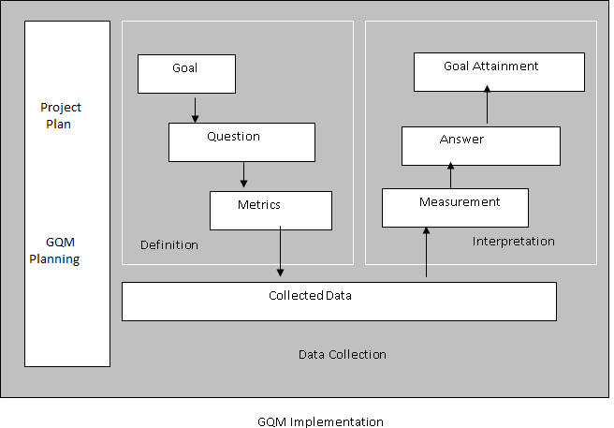

  - Data Collection

- During collection, data needs to be validated by checking for such things as data completeness, timeliness, and accuracy. Once validated, the data can be presented to the team and other appropriate recipients for interpretation.
- A key activity of this phase is to store the data in such a way that it facilitates access by the project team and others both during and after a project. Most GQM implementations develop a metric database for this purpose.

  - Interpretation

- After the data is collected, validated and prepared for review, interpretation involves review of the measurement results by the stakeholders (typically the project team).
- The team interprets the data in light of the questions asked and the ultimate goals defined. Do the measurement results provide answers to the questions addressed? To what extent has the goal been attained?
- Typically during the Interpretation phase the team determines not only the extent to which the actual measurements address their corresponding questions and the extent to which the measurement goals were attained, but also what improvements can be made to the measurement program itself.
- Success in interpretation is premised on the principle that the measurement program must address the interests of those providing the data and must be based on the project team’s knowledge.
- These feedback sessions typically lead to update the Measurement and Analysis Plans, and sometimes, to the alteration or addition of measurement goals. Keep in mind that measurement goals may be related to the product as well as the process or resources.
- The visibility of information provided by the presentation format of the measurement results makes it easier for the project team to take corrective action during the project, since they are monitoring progress on a periodic basis. They use the quantitative information for fact-based decision-making.
- This phase also addresses making decisions about the preservation of measurement results for use in the future and lessons learned.
- GQM Architecture

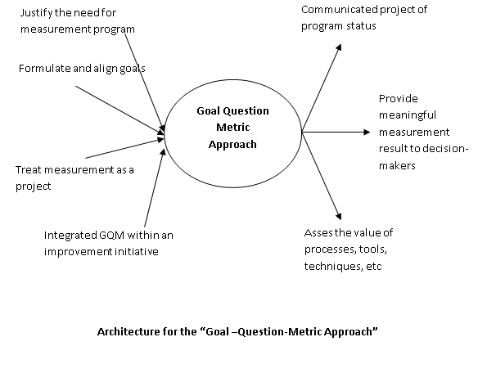

Inputs from the Practice

Justify the Need for a Measurement Program

There is a cost associated with implementing any type of measurement program. Without management commitment, it is difficult to create or sustain an effective measurement program. Developing and Maintaining a Life-Cycle Business Case, in which you communicate the alignment of the measurement goals with the business goals, is a key factor. Lack of such a business case sets the stage for failure.

Formulate and align goals

- Since goals drive the identification of metrics in the GQM paradigm, if the organization and project is accustomed to defining and communicating goals, then the task of identifying measurement goals is easier. Practices that support goal articulation at any level will likely be a positive influence on the GQM practice.
- Requirements Management and Requirements Trade-Off/Negotiations have a positive impact because they focus on documenting and prioritizing requirements. Many high level requirements are actually synonymous with project level goals. Getting the viewpoint of key people is one of GQM’s success factors.
- Establish Clear Goals and Decision Points is a program or organizational level practice that establishes overall goals and a schedule for reviewing progress and achievement in order to determine the future of the program. This provides clear guidance to serve as a basis for establishing the measurement plan.

Treat Measurement as a Project

The implementation of any metrics program needs to be addressed in much the same way as a software development project, although it is integrated within the target project(s). Significant planning is required initially; there are iterations or cycles of the measurement process where plans are implemented, feedback occurs, and then the plans are revised.

Integrate GQM within an improvement initiative

Since GQM is, itself, an iterative process with a built in improvement cycle, having an overall improvement initiative within the organization or program for which GQM provides data has a positive impact on the GQM implementation.

Outputs from the Practice

Communicate project or program status

Since GQM includes analysis and interpretation stages that focus on whether the goals have been addressed, data is organized and aggregated to optimize interpretation and use and to focus on what is deemed most relevant. This makes it easier to communicate project/program status in whatever perspectives are needed. It is scalable and flexible enough to support tracking Earned Value for efforts,, Defect Tracking against Quality Targets.

Provide meaningful measurement results decision-makers

A major benefit of GQM is the relevance of the measurement results to key decision makers. GQM therefore, facilitates such practices as Metrics-Based Scheduling and Management, Quantitative Progress measurement, and Independent Expert Reviews (e.g., maturity assessments).

Assess the value of processes, tools and techniques

The successful implementation of GQM establishes a mindset and a structure for experimenting with various processes, tools and techniques to determine their value to the overall software development process or project. It provides both the planning and assessment framework in which to perform evaluations to determine the effectiveness of the process within the project or program environment. Organizations have used GQM to monitor and assess such practices as Formal Inspections, Assessing Reuse Risks and Costs and Statistical Process Control.

